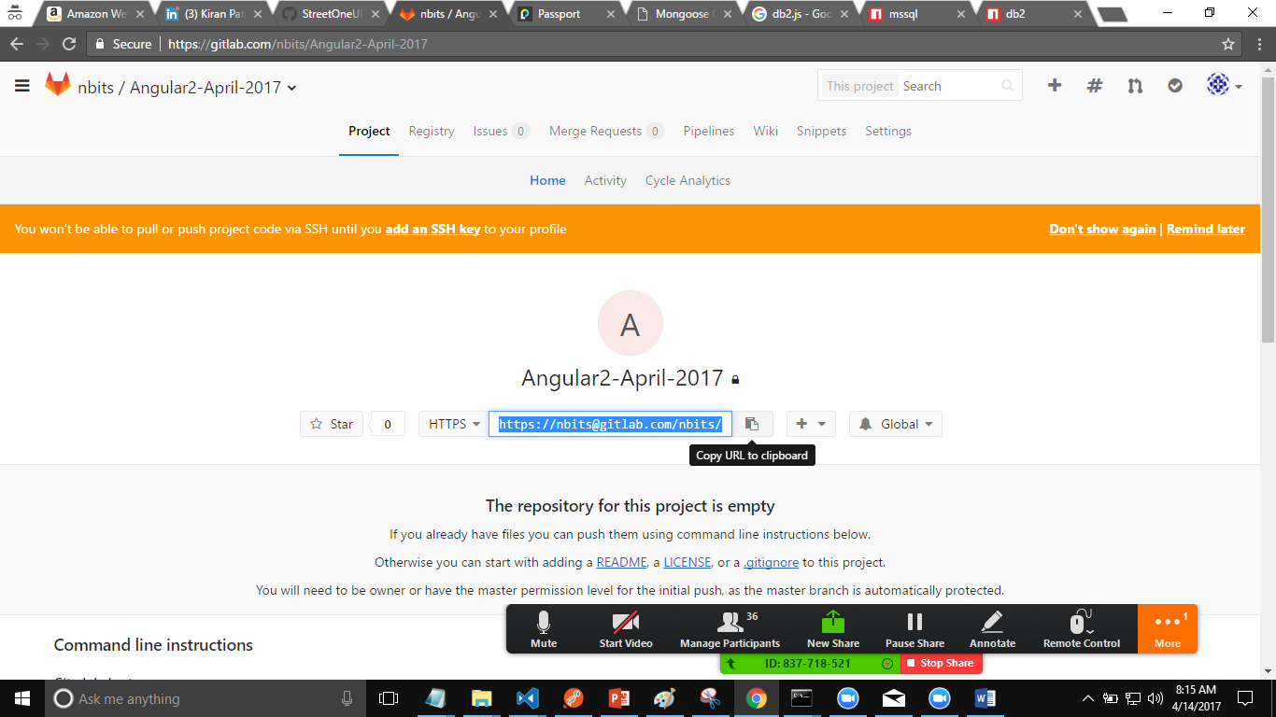

Create your learning directory.

Open the command prompt in that directory.

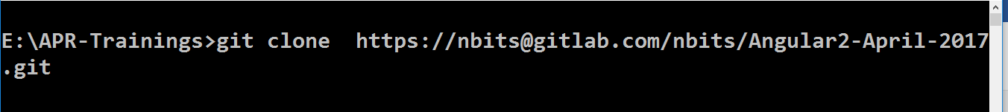

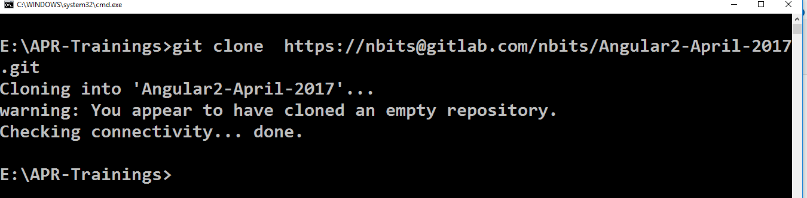

To go the the code

“ git checkout master”

“git pull”

Git checkout <date> mm-dd-yyyy